Annual health checks survey
Name of surgery:
Where are you filling in this survey today? This might be at your day service, in your own home, with your family or carer, or somewhere else:

Patient number:

 | Do you know what an annual health check is? | Answer | Comments from interviewer
 | In the last year, did your GP offer you an annual health check? | - Yes  - No  - Yes but I did not want a health check  - Not sure
 | If you had a letter was it written in a way to help you understand it? | Answer | Comments from interviewer
 | Were you given a choice about how and where your annual health check took place? For instance, in person, on a video or by telephone? | Yes  No
 | How did your annual health check take place: face to face/in person  On a video/zoom  Or by telephone | In person  Video/zoom  By Telephone
 | Do you remember having your annual health check? | Answer | Comments from interviewer
Did someone explain what an annual health check was for?
If so, who explained it?
 | Who did your health check? A doctor, a nurse or someone else? | Doctor  Nurse  Someone else?
 | During the annual health check do you think the doctor/ nurse that asked you questions listened to you? | Answer | Comments from interviewer
 | Did you get chance to ask them any questions?
 | Were there any questions you'd have liked to ask but didn't?
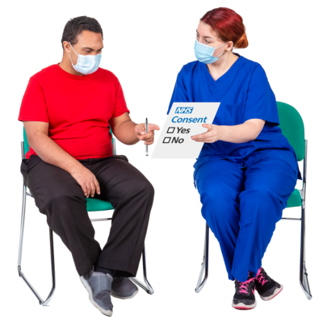 | Did they give you any extra support? This might have been something like giving you extra time | Answer | Comments from interviewer
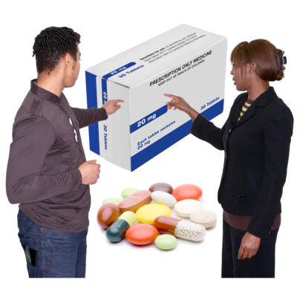 | If you take tablets or medicine, did they tell you what they are for?
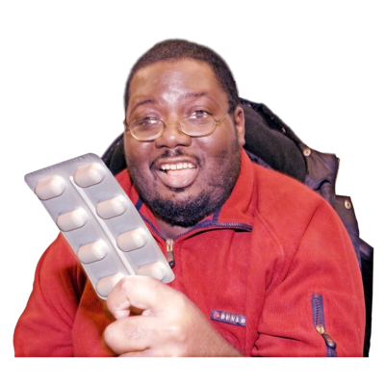? | If not, do you take any tablets or medicine but are not sure why?
 | Did they check your medication was right for you? | Answer | Comments from interviewer
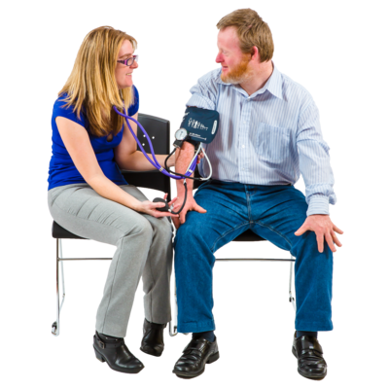 | Did they check your body by listening to your heart or checking your blood pressure?
 | Did they check your wee?
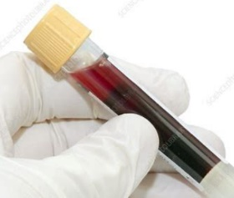  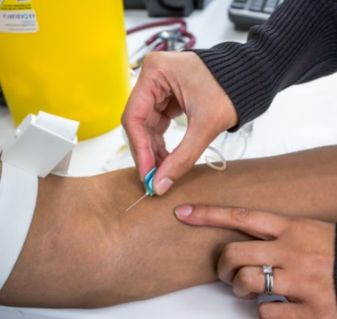 | Did they take your blood in a bottle for testing? | Answer | Comments from interviewer
 | Did they ask you about what you eat and drink?
 | Did they ask you how you were feeling?
 | At the end did they do a health action plan with you? | Answer | Comments from interviewer
 | Can you remember what it has in it?  Would you be happy for me to see it? | Remember it?  Can I see it?
 | Do you think your doctor is good, or could they do better?  If you think they could do better please tell us how? | Good  Could be better  How could they do better: | Comments from interviewer
 | If you make your own appointments, do you find this  easy to do,  a bit hard or  very hard? | Answer  Easy  A bit hard  Very hard | Comments from interviewer
 | We do not need to give us your name or contact details. But NHS Northamptonshire Clinical Commissioning Group is running a prize draw for everyone who takes this survey. This gives you a chance to win a £25 High Street voucher.
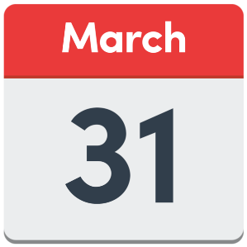 | If you would like to be entered into the prize draw please give us a phone number, an email address or postal address. The draw will take place on 31 March. We will choose just one person from all the entries we receive. We will only use your contact details here if you win the draw. | Contact details to enter the prize draw:

Your image here | Score key  1 = Really good experience of annual health check with a health action plan  2 = Good experience of annual health check with a health action plan  3 = Poor experience of annual health check with no health action plan

