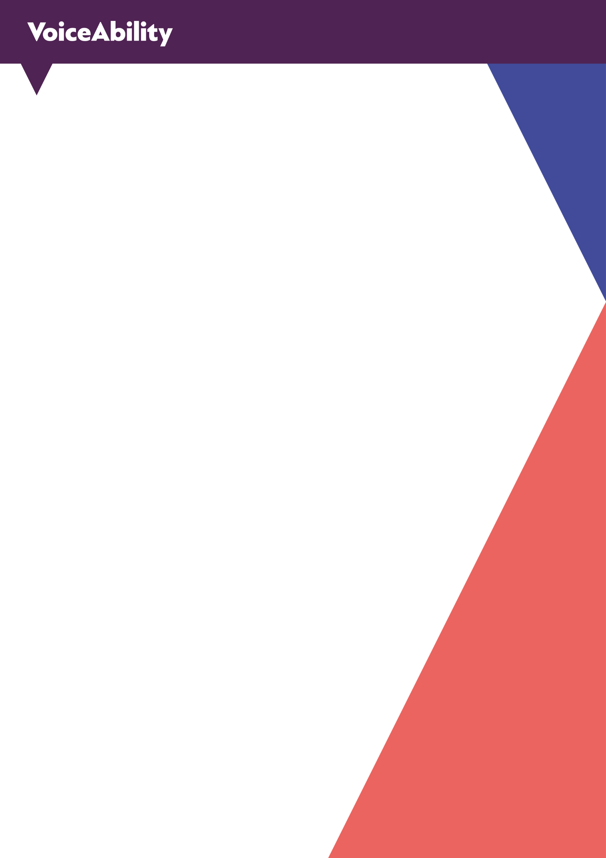

Gender Pay Gap Report

2025- 2026

Gender Pay Gap Report: Snapshot 31 March 2026

Introduction

VoiceAbility believes in fostering an inclusive workplace which welcomes, values and celebrates the diversity of its staff, clients and stakeholders. It treats all on a basis of equality and encourages all to meet their maximum potential. VoiceAbility will do all it can to ensure people are recruited, trained and promoted according to their qualifications, experiences and abilities for all roles in the organisation. We also seek to provide the best opportunities for all our employees based on their abilities and potential, which includes paying employees for the role they perform, regardless of their gender.

Under the Equality Act 2010 (Gender Pay Gap Information) Regulations we are required to produce a Gender Pay Gap report because it is a mandatory requirement for employers with 250 or more employees on the ‘snapshot date’ to calculate and publish gender pay gap figures each year. This applies to organisations in England, Scotland and Wales.

Under these regulations we need to publish

- Pay quartiles
- Mean pay gap between men and women
- Median pay gap between men and women
- The same figures for bonuses

VoiceAbility is an independent national charity and one of the UK’s largest providers of advocacy and involvement services. We have over 400 people throughout the UK working for us at the snapshot date, although we were required to report on 389 people during this year's snapshot date (based on earnings criteria).

Gender pay gap between men and women

These figures are based on hourly rates worked out on earnings over the ‘snapshot period’. The snapshot period is the specific date each year when we must take a “snapshot” of our colleague’s pay data for gender pay gap reporting. Everything in our report is based on who is employed on that exact date.

We do not pay ‘bonuses’ at Voiceability therefore there is no data to include in the report in these areas.

Totals
Total reportable colleagues | 389
Men | 78
Women | 311

Percentage Split | % Men | % Women
Lower hourly pay quarter | 20% | 80%
Lower middle hourly pay quarter | 14% | 86%
Upper middle hourly pay quarter | 14% | 86%
Upper hourly pay quarter | 31% | 69%

Mean Differences For Women | % | 2024/25 %
Total (All quarters) | 2% Lower | 10.22% Lower
Lower hourly pay quarter | 2.59% Higher | 4.29% Higher
Lower middle hourly pay quarter | 0.29% Lower | 0.16% Lower
Upper middle hourly pay quarter | 1% Lower | 2.39% Lower
Upper hourly pay quarter | 8% Higher | 9.12% Lower

Median Differences For Women | % | 2024/25 %
Total (All quarters) | 2% Lower | 4.02% Lower
Lower hourly pay quarter | 4% Higher | 1.21% Higher
Lower middle hourly pay quarter | 0% | 1.11% Lower
Upper middle hourly pay quarter | 0% | 3.79% Lower
Upper hourly pay quarter | 6% Higher | 4.46% Lower

Breakdown: What these figures mean

Summary

Whilst there is still work to do in closing the gap between men and women, VoiceAbility has made meaningful progress over the past year. Our overall mean gender pay gap has reduced by more than 8%, and our median gap has narrowed by over 2%. These improvements reflect the positive movement we are seeing across our organisation.

Our workforce remains predominantly female, and we are pleased to see more women than ever progressing into the upper hourly pay quartile. However, there is still a higher concentration of men in the upper quartiles, and this—combined with a slightly higher male median hourly rate—continues to keep our overall median gap at 2%.

We recognise this challenge and remain committed to addressing it. Our focus is on creating a fair, transparent and equitable pay structure that supports progression for everyone, regardless of gender.

What’s causing the gap

When we look at our mean figures, women are now earning more per hour than men in both the lower and upper hourly pay quartiles, with only a marginal difference remaining in the middle quartiles. This represents real progress. However, the overall mean gap is still influenced by the higher concentration of men in the upper quartiles, which continues to pull the average male hourly rate slightly higher.

Our median figures tell a similar story. Women are earning more than men in the upper and lower quartiles, and men and women are now earning equally in the middle quartiles — a positive sign of increasing balance. Yet, our overall median gap remains at 2%. This is largely due to the distribution of our workforce: more men sit in the upper quartiles and more women in the lower quartiles. As a result, the ‘middle man’ is positioned higher in the pay structure than the ‘middle woman’, which keeps the median gap open.

While these figures highlight where the gap exists, they do not explain why. By looking more closely at our data, we can see that one of the key drivers is length of service. On average, male colleagues have been with VoiceAbility longer than female colleagues. Historically, our pay structure has been linked to length of service, meaning longer‑serving male colleagues have had greater opportunity to progress through the pay scale, while women — who typically have shorter average service — have not yet reached the same point.

This insight does not excuse the gap, but it does help us understand it — and, importantly, it gives us a clear area to focus on as we continue our work to create a fairer and more equitable pay structure for everyone.

Length of service | Years
Average length of service for men | 3.74
Average length of service for women | 2.64
Percentage difference | 29% lower

Successes

- Our mean gender pay gap has reduced by 8.22 percentage points, reflecting a strong shift toward greater pay equality across the organisation.
- Our median gender pay gap has narrowed by 2.02 percentage points, demonstrating continued progress in balancing pay at the midpoint of our workforce.
- We now have a stronger distribution of women in more senior and higher‑paid roles, showing positive movement in career progression and representation.
- There is no median pay disparity in the middle quartiles, highlighting that men and women are now paid equally at the core of our pay structure.

Next Steps

- We will continue to strengthen pay progression for women in the lower quartiles, ensuring that opportunities for development and advancement are accessible and equitable across all levels of the organisation.
- We aim to increase the representation of women in the upper quartile, supporting more women to progress into senior and higher‑paid roles through targeted development, career pathways and fair recruitment practices.
- We have identified length of service as a key factor influencing our gender pay gap, with male colleagues currently having a higher average tenure. This has historically enabled greater progression through our pay structure. Understanding this gives us a clear opportunity: to explore ways of improving average length of service for women, strengthening retention, and ensuring that progression is based on fair and transparent criteria.

Conclusion

At VoiceAbility, we are proud of the meaningful progress we have made in closing the gender pay gap over the past 12 months. This year marks a turning point: we are moving with purpose toward a future where pay is driven by experience, skill and contribution — never by gender.

Our commitment to fairness runs deeper than numbers. We have strengthened the foundations needed for long‑term equality, investing in better data, clearer processes and a culture that recognises and rewards talent wherever it is found. These changes are already making a difference, and they reflect the values we stand for as an organisation.

We know there is still more to do, and we embrace that challenge. Our focus now is on building momentum — continuing to refine our practices, listening to our colleagues and using our insights to drive meaningful, lasting change.

We look forward to sharing further progress in the year ahead as we continue our journey toward true pay equality and a workplace where everyone can thrive.

